Fibre, A Forgotten Key to a Thriving Diet

Sarah Kate Walsh^{1,*}

¹ School of Food and Nutritional Sciences, University College Cork, Ireland.

* Corresponding Author: 115311501@umail.ucc.ie.
Summary
Fibre is an often-overlooked nutrient in the debate of what constitutes a healthy diet for optimal health and the prevention of chronic disease. This article aims to introduce fibre as an important dietary component including its role in the ancestral diet. It discusses current and recommended intakes and addresses the “fibre gap” observed in Western-style diets. The potential benefits of reformulating foods using isolated fibre ingredients are discussed including the work of the Microbe Restore project. Food reformulation to increase population fibre intakes may offer an important strategy to decrease the societal burden of diet-related chronic disease.
Keywords: fibre, diet, food reformulation, nutrition, food policy, food science and technology.

Let’s talk about fibre
What is fibre and why should we focus on it? Since the 1980s, surges in obesity rates have led researchers to investigate factors which contribute to the often termed “obesogenic environment”. That is, the factors within our food supply and living conditions that contribute to unhealthy weight gain and associated chronic disease. Much attention has focused on the food components that have significantly increased within our diet over the past few decades, notably fat, sugar, salt, and animal products (such as meat, eggs, dairy etc.). However, less attention is often given to key elements within our diet that have substantially decreased, such as dietary fibre.
Fibre is an important, though non-essential nutrient. Its most recognised health benefit is its ability to promote normal bowel function and reduce the risk of constipation. Though its role in colonic health is well established, emerging research supports a key role for dietary fibre in regulating appetite and satiety (the feeling of fullness), blood cholesterol levels, blood glucose(sugar) levels, and its potential prebiotic effects (ability to encourage the growth of beneficial gut bacteria) which may aid in promoting a healthy gut microbiome.

Current and recommended dietary fibre intakes
Information from the most recent National Adult Nutrition Survey noted that on average Irish Adults consume 19 g/day dietary fibre. These levels are substantially below the recommended30 g/day dietary fibre for adults set by the UK’s Scientific Advisory Committee for Nutrition (SACN). Recently, much attention has focused on developing strategies to help “bridge the fibre gap”, that is, the gap between current and recommended intakes.
Today, many people in Ireland and other industrialised nations consume what is referred to as a Western-style diet. This diet is high in processed foods such as white bread, biscuits, cakes, and processed meats (including sausages and bacon) and subsequently low in fibre rich foods such as fruits, vegetables, nuts, and legumes which represented substantial components of the diets of our ancestors (see Figures 1 and 2.)

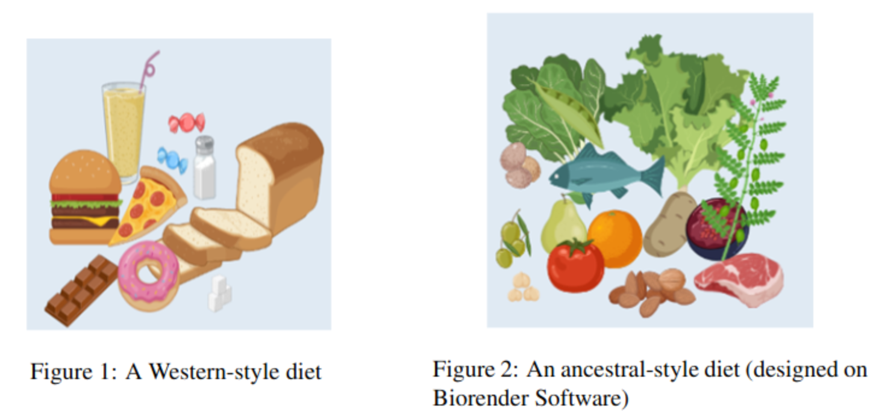
Reflecting on the diet of our ancestors
It is believed that our ancestors may have consumed over 100 g/day dietary fibre! Such in-takes are over five times higher than the average Irish adult today. High dietary fibre intakes representative of the ancestral diet may still exist today in some non-industrialised societies, or example in the Hadza hunter-gatherers of Tanzania and rural Papua New Guineans. These intakes may only be achieved by consuming large quantities of fibrous plant foods which would not likely appeal to the modern consumer’s taste palate.
Interestingly, data collected from rural Papua New Guineans who consume an unprocessed, high fibre ancestral-style diet have noted bacterial species within their gut microbiome that are depleted or no longer present in the gut of many individuals following a Western-style diet. Increasing evidence highlights that a healthy gut microbiome that contains a diverse and dense population of microorganisms may be a significant indicator of health by reducing one’s risk of developing many chronic diseases (such as obesity, type 2 diabetes mellitus and heart disease) which cripple healthcare systems in high- and low-income countries.
Many Westernized societies are noting an increase in overweight and obesity as well as a significant rise in auto-immune diseases, allergies, mental health, and neurological disorders which appear to be less prevalent in populations with high fibre intakes and rich and diverse gut microbiomes. Reflecting on current research, the restoration of fibre intakes and the modern consumer’s gut microbiome to resemble that of our ancestors may offer an array of health benefits.

Sources of dietary fibre
In addition to the fibre present in wholefoods including fruit and vegetables, wholegrains, nuts, and legumes such as peas, beans, lentils, and chickpeas, there is an emerging market for isolated fibre ingredients. These ingredients can be used to create “functional foods”, i.e., foods formulated to promote health benefits. Such isolated fibres may include resistant starch, beta-glucan, cellulose, and oat fibre. In their purified form they may more closely resemble refined flour ingredients such as white wheat flour and starches. At present, some of the perceived barriers to increasing fibre intakes often surround the taste and texture of high fibre foods, which may be perceived as coarse, dense, and dark in colour. These characteristics are commonly observed in traditional fibre enriching ingredients such as wholemeal flour, rye, and wheat bran.
Certain highly purified fibres may be more acceptable than traditional high fibre ingredients due to their pale colour, fine texture, and often neutral taste (see Figures 3 and 4). These properties may make them more attractive to the modern consumer whose food choice often favours taste and palatability over health consciousness. Food staples such as bread, pasta, biscuits, and cakes can be reformulated by replacing refined white flour with isolated fibres. This may offer a solution to overcome the negative consumer perception associated with traditional high fibre foods, providing a unique opportunity for food innovation and enterprise.

The Microbe Restore project
Here, within the School of Food and Nutritional Sciences and the APC Microbiome Ireland we are asking the question – Can a processed Western-style diet be reformulated to increase dietary fibre intakes to reflect those observed in the ancestral diet? Can this be achieved with-out negatively affecting the taste, texture, and acceptability of staple Western food products? Additionally, what are the associated health effects of such a diet in overweight and obese Irish adults?
By reformulating a typical Western style/modern Irish diet with isolated and synthetic fibres and providing participants all their daily meals for several weeks we aim to evaluate multiple health outcomes. Changes in the participant’s gut microbiome will be monitored by collecting and analysing faecal samples. Such data may help us determine if some “missing” bacteria maybe re-established in the modern human gut microbiome and if the number of bacteria present may increase to levels observed in non-industrialised populations. Additionally, blood sample swill be collected to analyse any changes in cholesterol levels or markers for diabetes. As dietary fibre may increase one’s feeling of fullness after eating, we will also monitor the participant’s weight and overall food consumption during the study period. Together, this information will allow us to assess the health effects, feasibility, and acceptability of a reformulated high fibre Western-style diet, in a sample of overweight and obese Irish adults.

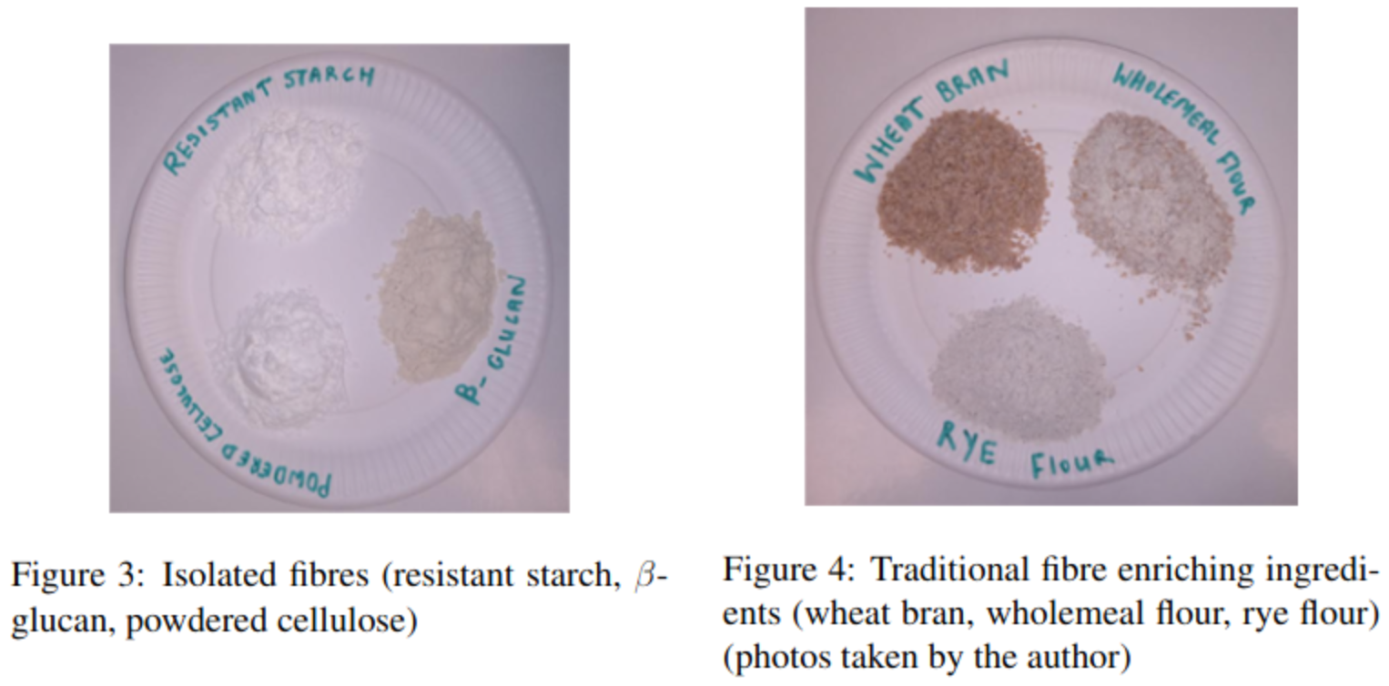
Future food reformulation to tackle public health concerns
Although there is an increasing market for probiotic and prebiotic supplements which target gut health, the reformulation of staple foods may offer an accessible and cost-effective opportunity to support digestive health and increase fibre intakes in a wider audience who may wish to take a “food first” approach. Such approaches aim to increase nutrient intakes from foods and beverages where possible rather than supplements.
Initiatives such as the Food and Drink Federation’s “Action on Fibre” campaign aim to encourage food reformulation within the food industry to “make higher fibre diets more appealing, normal, and easy for the population”. Many leading members of the global food industry have pledged to participate in the campaign including Nestle, Kellogg’s, Quorn, and General Mills. By encouraging the reformulation of popular processed foods to increase fibre intakes and maintain product acceptability (taste, appearance etc.), the initiative aims to provide strategies to help “bridge the fibre gap” between current and recommended intakes which is a public health concern. Research such as the Microbe Restore project will provide underpinning evidence to the food industry and food legislation authorities to encourage food reformulation to increase population fibre intakes, offer greater food choice and accessibility of functional food products and decrease one’s risk factors for numerous chronic diseases.

Acknowledgements
Thanks to my supervisors and academic advisors Prof. Jens Walter, Dr Alice Lucey, and Prof Elke Arendt and colleagues in the School of Food and Nutritional Sciences/APC Microbiome Ireland (especially Victoria MacMahon for her help and support and Mr Tom Hannon for supplying the fibres in Figures 3 and 4).

Declaration of interests
None. This publication has emanated from research supported by a grant from Science Foundation Ireland under grant number 19/RP/6853. All ethical guidelines relating to the research and publication process were adhered to throughout this study.

Author Bio
Sarah is a third year PhD student in Nutritional Sciences. Her research focuses on reformulating processed foods using isolated fibres and their associated health impact by running clinical dietary trials. She is based between the School of Food and Nutritional Sciences and the APC Microbiome Ireland. Sarah enjoys communicating her research and raising awareness about the importance of dietary fibre and the gut microbiome through various education and public engagement activities including writing for RTE Brainstorm and presenting at the Pint of Science “Our Society” event.

The gut microbiome refers to the trillions of microorganisms that reside in the gastrointestinal tract.
Probiotics are live microorganisms intended to have health benefits when consumed.

